**2-Program to implement Lamport’s Logical Clock**

***Lamport's Logical Clock***, introduced by computer scientist Leslie Lamport in 1978, is a concept used in distributed systems to establish a partial order of events in a distributed system. It is not a physical clock that keeps track of time but rather a mechanism for maintaining a logical order of events based on timestamps. The primary purpose of Lamport's Logical Clock is to provide a way to reason about the relative order of events in a distributed system, even when there is no global clock or synchronized time.

**C++ CODE**

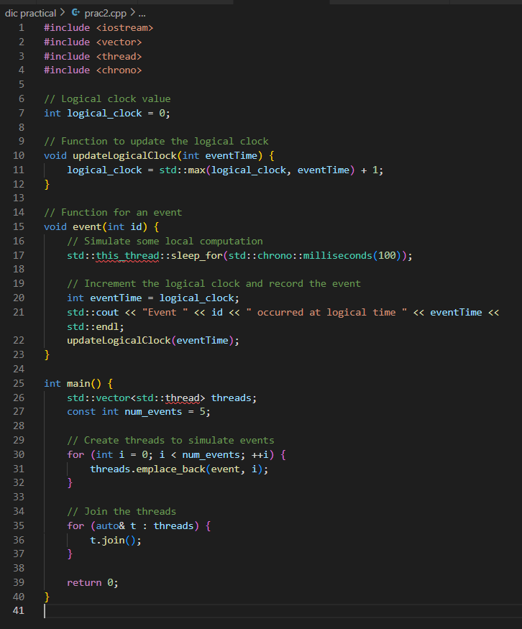

OUTPUT:

